PILATES CORE UNITS MAPPING TOOLKIT
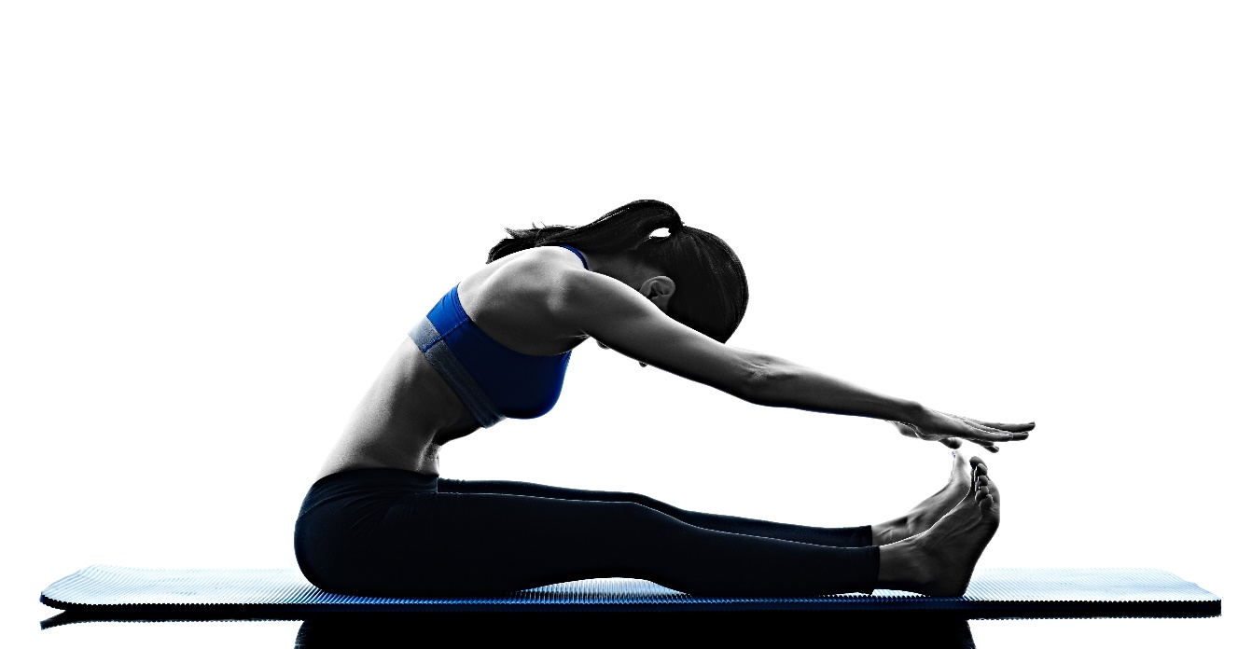

Table of Contents

Overview of Pilates Core Standards 2
PC1 Scope of practice and professional responsibilities Pilates Teacher 3
PC2 The Principles, fundamentals, philosophy and origins 4
PC3 Effective programming of the Pilates method 6
PC4 Teaching the Pilates method 8

Overview of Pilates Core Standards
These standards have been designed for training providers to map to when submitting their Pilates Reformer Instructor qualification, where the prerequisite includes appropriate Level 3 fitness qualifications.
These units are designed to support the planning and teaching of a Pilates Reformer session for apparently healthy adults of all ages.
The standards cover the core units of Pilates:
- Responsibilities and scope of practice for Pilates Teachers (2 GLH)
- The principles, fundamentals, philosophy and origins of the Pilates method (5 GLH)
- Effective programming of the Pilates method (8 GLH)
- Teaching the Pilates method (10 GLH)
Total guided learning hours (GLH): 25
Guided learning is defined as the learner being supported in a range of environments such as classroom based, independent learning, online tutorials, or through calls with the tutor/assessor, and completing a structured task that is then given feedback from their tutor or assessor. This feedback may be formative or summative.
Review
These standards will be reviewed annually. Any feedback can be sent to enquiries@pdapproval.com.

PC1 Scope of practice and professional responsibilities Pilates Teacher
The Guided Learning Hours (GLH) required to deliver and assess this unit are 2 hours.
Knowledge requirements  This unit covers the following knowledge, which must be delivered in full | - PT1.1 Scope of practice of a Pilates Teacher  - PT1.2 Professional responsibilities of a Pilates Teacher
Learning outcomes  which must be assessed in full: | The learner will be able to:  - Identify the scope of practice for a Pilates Teacher  - Identify the professional responsibilities of a Pilates Teacher
Assessment strategy  Methods to assess the learning outcome | - Written text (open book)  - Professional discussion

Learning outcome  The learner will be able to | Where is this covered in your resources? | How is it assessed?
PT1.1 Scope of practice of a Pilates Teacher
- Explain the purpose of a scope of practice
- Identify the scope of practice for a Pilates Teacher
- Identify what is outside of the scope of practice for a Pilates Teacher
PT1.2 Professional responsibilities of a Pilates Teacher
- Identify the professional responsibilities of a Pilates Teacher to include:
- personal responsibilities
- professional responsibilities ie insurance and licences
- personal development

PC2 The Principles, fundamentals, philosophy and origins
The Guided Learning Hours (GLH) required to deliver and assess this unit are 5 hours
Knowledge requirements  This unit covers the following knowledge, which must be delivered in full | - PC2.1 The History and origins of the Pilates method  - PC2.2 The full Pilates System  - PC2.3 The fundamentals, philosophy and principles of Pilates
Learning outcomes  which must be assessed in full | The learner will be able to:  - Describe the historical background and origins of the Pilates method.  - Identify key influences on the development of Pilates  - Understand how historical context influenced Pilates principles and exercises.  - Reflect on how the original intent of Pilates informs modern practice  - Define what is meant by the full Pilates system.  - Identify the components of the Pilates system  - Explain how the system was designed to work as an integrated whole rather than isolated exercises.  - Understand the original intentions of Joseph Pilates in developing a complete method of physical conditioning.  - Apply an understanding of the full system to modern Pilates teaching and programming.  - Describe the fundamental principles underpinning the Pilates method  - Explain the philosophy of Pilates as a mind–body system.  - Demonstrate understanding of how the principles guide movement quality and exercise execution.  - Apply Pilates fundamentals and principles to teaching
Assessment strategy  Methods to assess the learning outcome | - Written text (open book)  - Professional discussion

Learning outcome  The learner will be able to | Where is this covered in your resources? | How is it assessed?
PC2.1 The history and origins of the Pilates method
- Describe the historical background and origins of the Pilates method.
- Identify key influences on the development of Pilates
- Understand how historical context influenced Pilates principles and exercises.
- Reflect on how the original intent of Pilates informs modern practice
PC2.2 The full Pilates System
- Define what is meant by the full Pilates system.
- Identify the components of the Pilates system
- Explain how the system was designed to work as an integrated whole rather than isolated exercises.
- Understand the original intentions of Joseph Pilates in developing a complete method of physical conditioning.
- Apply an understanding of the full system to modern Pilates teaching and programming.
PC2.3 The fundamentals, philosophy and principles of Pilates
- Describe the fundamental principles underpinning the Pilates method
- Explain the philosophy of Pilates as a mind–body system.
- Demonstrate understanding of how the principles guide movement quality and exercise execution.
- Apply Pilates fundamentals and principles to teaching

PC3 Effective programming of the Pilates method
The Guided Learning Hours (GLH) required to deliver and assess this unit are 8 hours
Knowledge requirements  This unit covers the following knowledge, which must be delivered in full | - PC3.1 The Methodology behind the Pilates exercise sequence  - PC3.2 Programming the right level  - PC3.3 Planning a Pilates session
Learning outcomes  which must be assessed in full | The learner will be able to:  - Explain the rationale behind the original Pilates exercise sequence.  - Describe the role of repetition in developing effective movement habits.  - Identify the key principles underpinning Pilates sequence methodology.  - Explain why exercise order and progression are fundamental to the integrity of the Pilates method.  - Apply sequencing principles to Pilates teaching while maintaining methodological integrity.  - Explain why correct level selection is essential to effective Pilates teaching.  - Identify the key characteristics and teaching priorities for beginner Pilates clients.  - Describe appropriate progression strategies for improver and improver-plus levels.  - Explain the defining features and demands of advanced Pilates programming.  - Apply level-appropriate programming principles to client scenarios while maintaining the integrity of the Pilates method  - Explain the importance of planning a Pilates session while remaining flexible and responsive.  - Identify key considerations when planning a Pilates class (audience, venue, equipment).  - Define clear session objectives aligned with Pilates methodology.  - Structure a balanced Pilates session using logical sequencing and progression.  - Plan appropriate adaptations, modifications, and teaching strategies for diverse client needs.
Assessment strategy  Methods to assess the learning outcome | - Written text (open book)  - Case study  - Session planning  - Professional discussion

Learning outcome  The learner will be able to | Where is this covered in your resources? | How is it assessed?
PC3.1 The Methodology behind the Pilates exercise sequence
- Explain the rationale behind the original Pilates exercise sequence.
- Describe the role of repetition in developing effective movement habits.
- Identify the key principles underpinning Pilates sequence methodology.
- Explain why exercise order and progression are fundamental to the integrity of the Pilates method.
- Apply sequencing principles to Pilates teaching while maintaining methodological integrity.
PC3.2 Programming the right level
- Explain why correct level selection is essential to effective Pilates teaching.
- Identify the key characteristics and teaching priorities for beginner Pilates clients.
- Describe appropriate progression strategies for improver and improver-plus levels.
- Explain the defining features and demands of advanced Pilates programming.
- Apply level-appropriate programming principles to client scenarios while maintaining the integrity of the Pilates method.
PC3.3 Planning a Pilates session
- Explain the importance of planning a Pilates session while remaining flexible and responsive.
- Identify key considerations when planning a Pilates class (audience, venue, equipment).
- Define clear session objectives aligned with Pilates methodology.
- Structure a balanced Pilates session using logical sequencing and progression.
- Plan appropriate adaptations, modifications, and teaching strategies for diverse client needs.

PC4 Teaching the Pilates method
The Guided Learning Hours (GLH) required to deliver and assess this unit are 10 hours
Knowledge requirements  This unit covers the following knowledge, which must be delivered in full | - PC4.1 Teaching the Pilates method
Learning outcomes  which must be assessed in full | The learner will be able to:  - Explain the staged teaching process used when delivering the Pilates method.  - Demonstrate understanding of effective transitions, exercise naming, and demonstration choices.  - Apply correct foundational set-up principles to Pilates exercises.  - Explain how flow, observation, correction, and teaching points support client learning.  - Use appropriate teaching language, visualisation, and hands-on correction safely and professionally.
Assessment strategy  Methods to assess the learning outcome | - Written text (open book)  - Case study  - Session planning  - Practical observation of teaching  - Professional discussion

Learning outcome  The learner will be able to | Where is this covered in your resources? | How is it assessed?
PC4.1 Teaching the Pilates method
- Explain the staged teaching process used when delivering the Pilates method.
- Demonstrate understanding of effective transitions, exercise naming, and demonstration choices.
- Apply correct foundational set-up principles to Pilates exercises
- Explain how flow, observation, correction, and teaching points support client learning.
- Use appropriate teaching language, visualisation, and hands-on correction safely and professionally.

